**Description**

As a user I should be able to click on search button “Lets eat “ so that I can see activities for the search keyword and zipcode I entered.

------------------------------------------------------------------------------------------------------------------------------------------

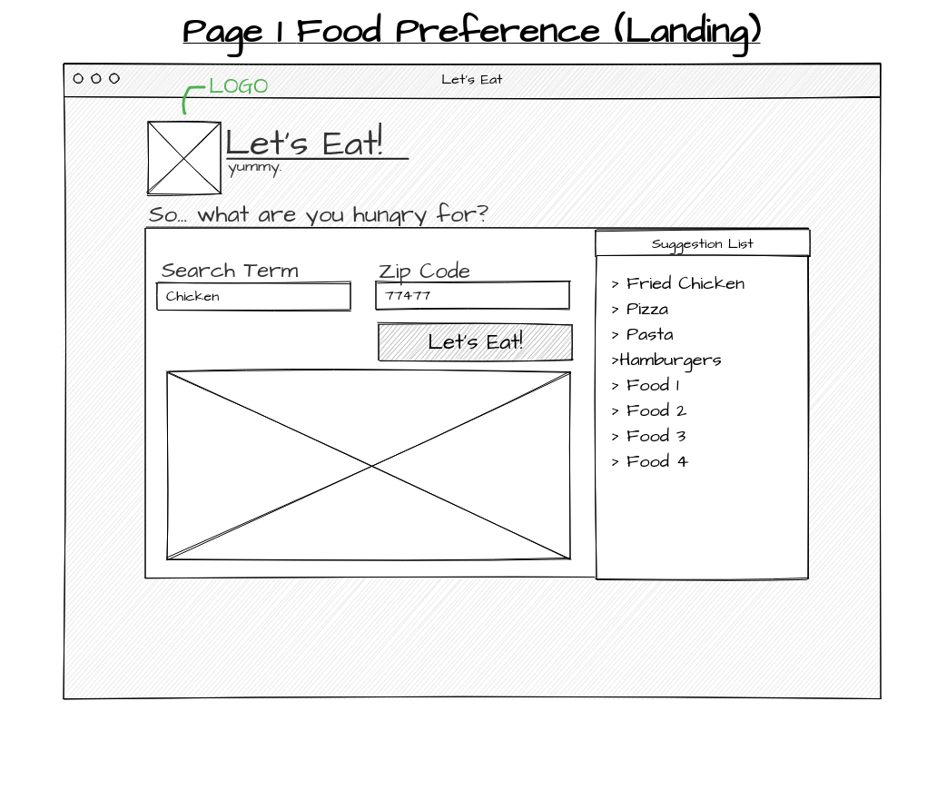

**Acceptance criteria**

* Able to make ajax call with API that is approved by the team
* Able to receive success or error.